Exp:7-Determination andplottingof Capacitance of isolatedandconcentricsphere withdifferentinnerandouterradiusanddielectricconstantofthedielectricmediums.

Aim:
TowriteprogramforCapacitanceofanisolatedsphereandtwoconcentric sphere using SCILAB.

Softwarerequired:
- SCILAB version6.0.1

Theory: Program:
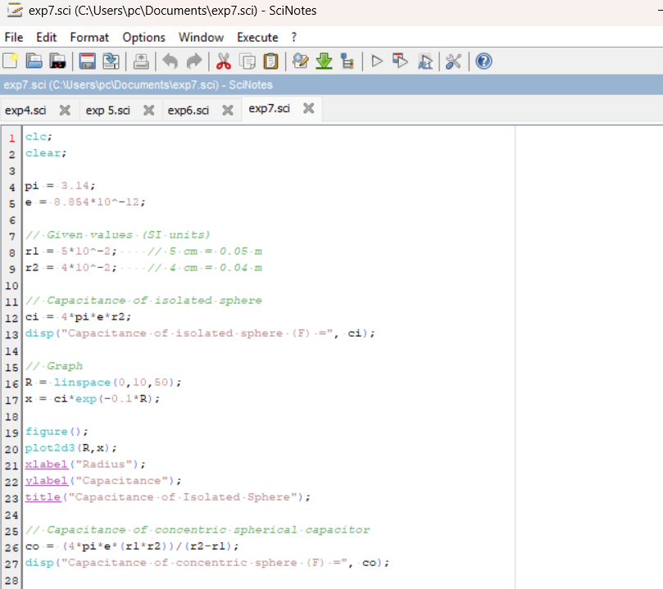

Output:
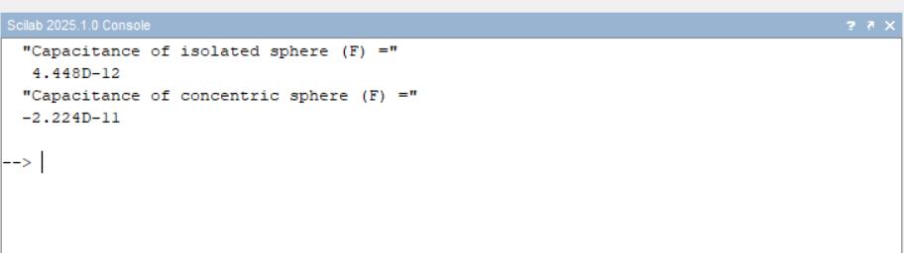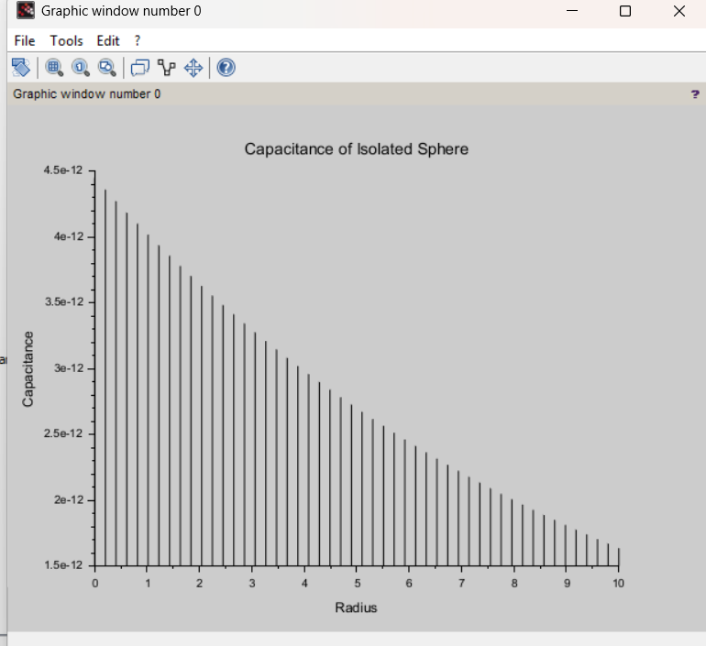

Calculation:

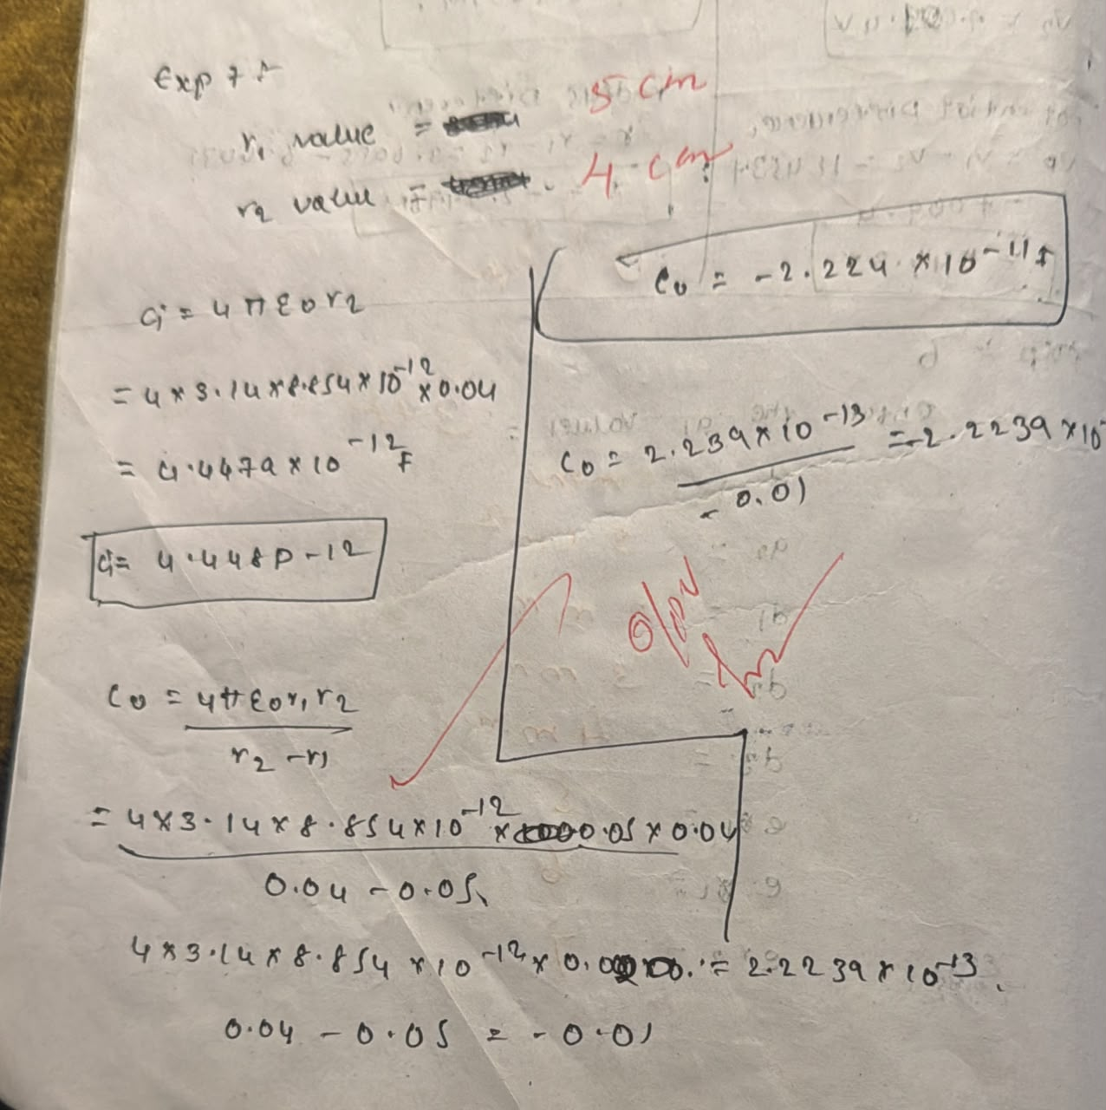

CASE1:-CONCENTRICSPHERICALCAPACITORWITHDIFFERENTDIELECTRIC MEDIUMSCODE:-

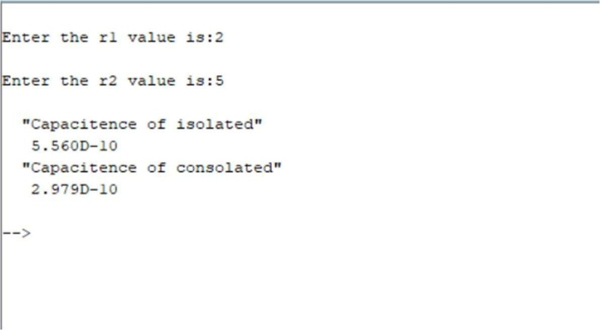

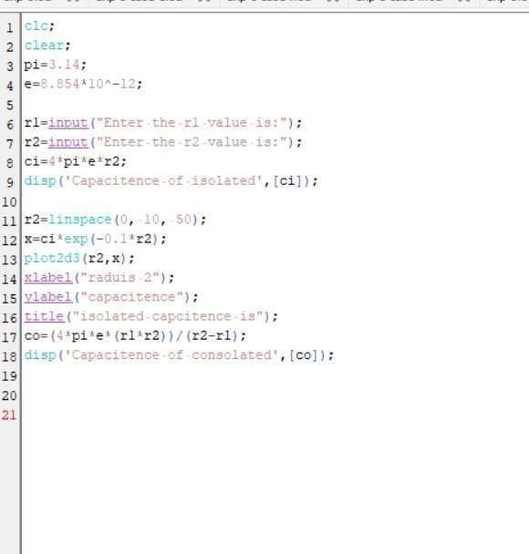
Output:
CASE2:ISOLATEDSPHERE CODE:-

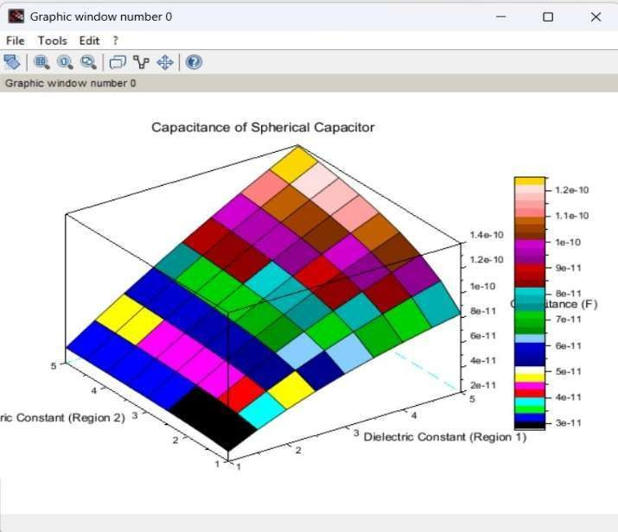

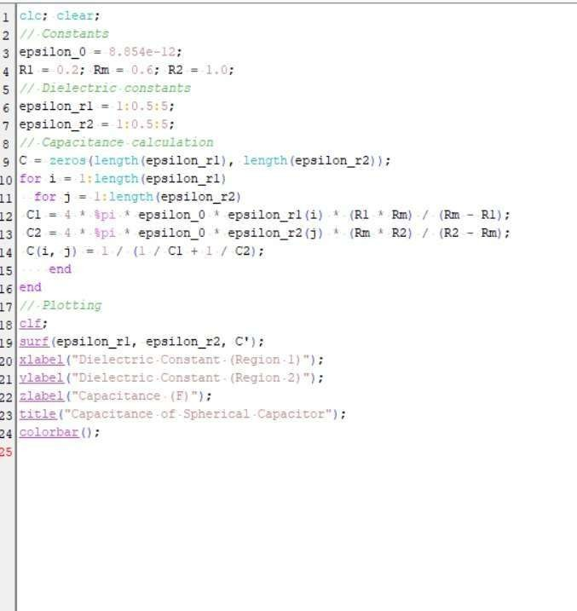
Output:
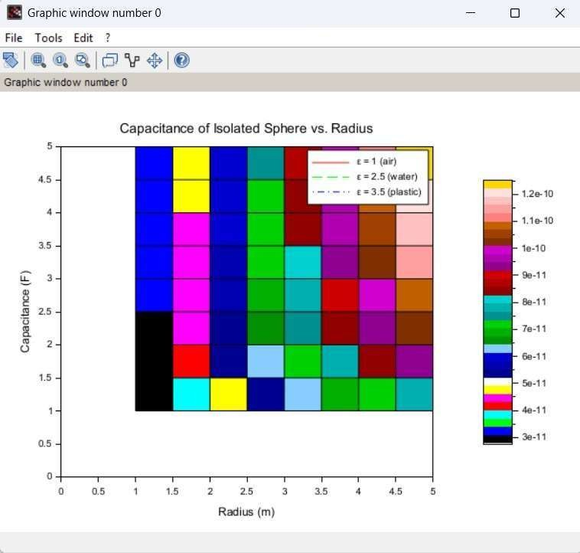

CASE3:CONCENTRICSPHERICALCAPACITOR CODE:

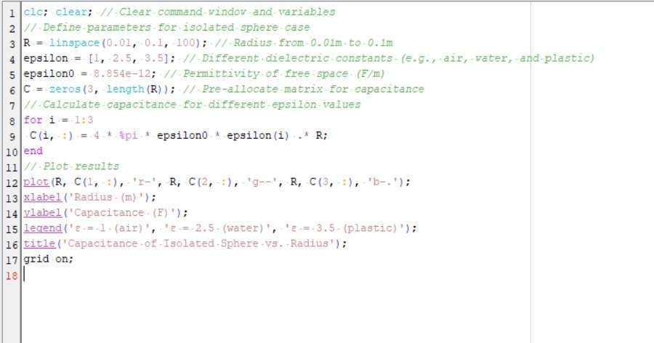
Output:
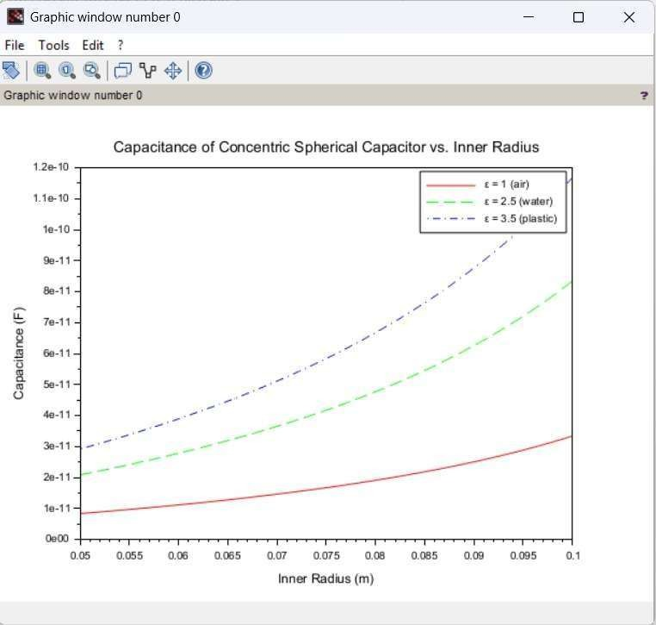

Result:
ThustheprogramwasverifiedforCapacitanceofanisolatedsphereandtwo concentric sphere using SCILAB was successfully.

